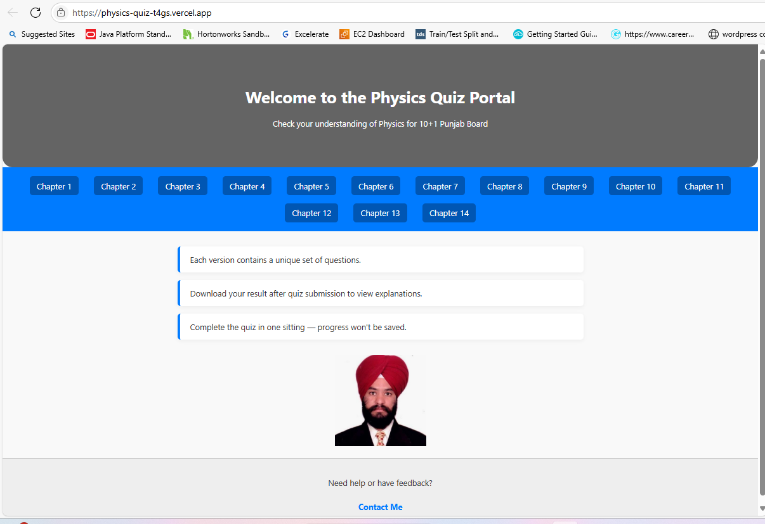

View inside MS-Edge Browser as deployed on Vercel

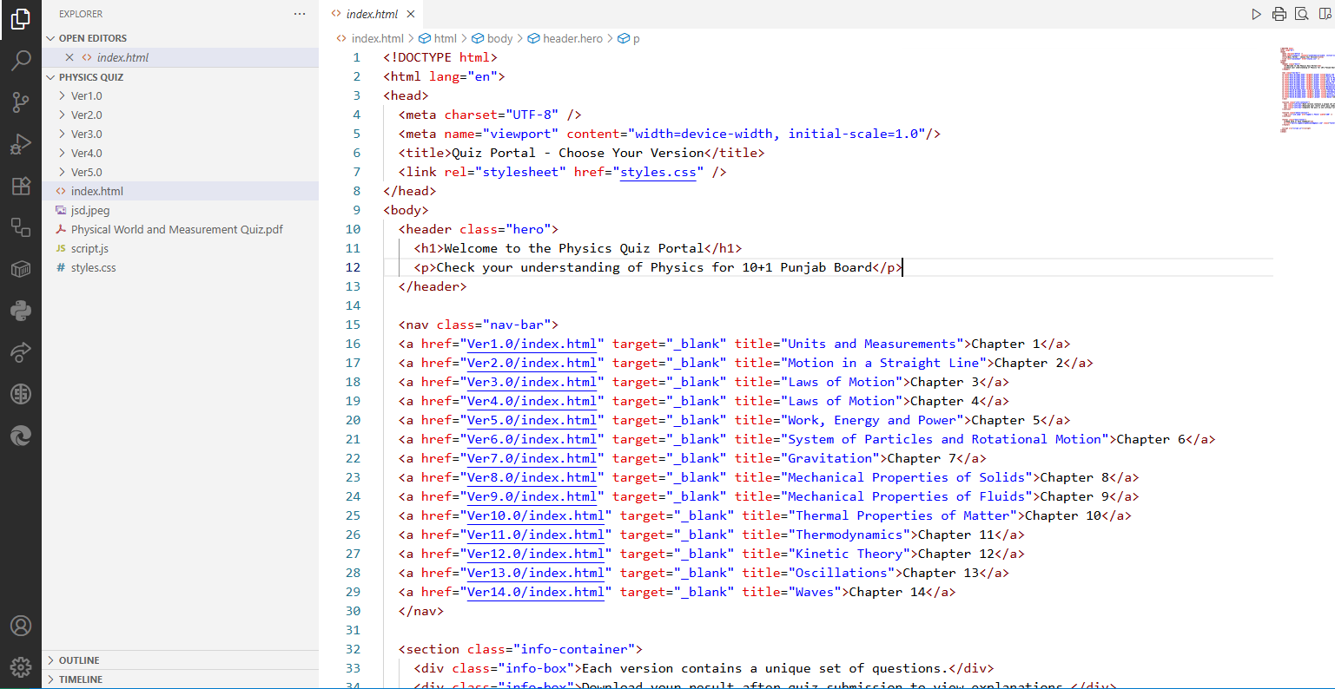

Snapshot of Directory Structure of Quiz App in VS Code

Code Work:

1. Inside Project Directory
2. index.html

<!DOCTYPE html>

<html lang="en">

<head>

  <meta charset="UTF-8" />

  <meta name="viewport" content="width=device-width, initial-scale=1.0"/>

  <title>Quiz Portal - Choose Your Version</title>

  <link rel="stylesheet" href="styles.css" />

</head>

<body>

  <header class="hero">

    <h1>Welcome to the Physics Quiz Portal</h1>

    <p>Check your understanding of Physics for 10+1 Punjab Board</p>

  </header>

  <nav class="nav-bar">

  <a href="Ver1.0/index.html" target="_blank" title="Units and Measurements">Chapter 1</a>

  <a href="Ver2.0/index.html" target="_blank" title="Motion in a Straight Line">Chapter 2</a>

  <a href="Ver3.0/index.html" target="_blank" title="Laws of Motion">Chapter 3</a>

  <a href="Ver4.0/index.html" target="_blank" title="Laws of Motion">Chapter 4</a>

  <a href="Ver5.0/index.html" target="_blank" title="Work, Energy and Power">Chapter 5</a>

  <a href="Ver6.0/index.html" target="_blank" title="System of Particles and Rotational Motion">Chapter 6</a>

  <a href="Ver7.0/index.html" target="_blank" title="Gravitation">Chapter 7</a>

  <a href="Ver8.0/index.html" target="_blank" title="Mechanical Properties of Solids">Chapter 8</a>

  <a href="Ver9.0/index.html" target="_blank" title="Mechanical Properties of Fluids">Chapter 9</a>

  <a href="Ver10.0/index.html" target="_blank" title="Thermal Properties of Matter">Chapter 10</a>

  <a href="Ver11.0/index.html" target="_blank" title="Thermodynamics">Chapter 11</a>

  <a href="Ver12.0/index.html" target="_blank" title="Kinetic Theory">Chapter 12</a>

  <a href="Ver13.0/index.html" target="_blank" title="Oscillations">Chapter 13</a>

  <a href="Ver14.0/index.html" target="_blank" title="Waves">Chapter 14</a>

  </nav>

  <section class="info-container">

    <div class="info-box">Each version contains a unique set of questions.</div>

    <div class="info-box">Download your result after quiz submission to view explanations.</div>

    <div class="info-box">Complete the quiz in one sitting — progress won't be saved.</div>

  </section>

  <section class="photo-section">

    <img src="/jsd.jpeg" alt="Jagdev's Photo" width="180" />

  </section>

  <footer class="main-footer">

    <p>Need help or have feedback?</p>

    <a href="mailto:jagdevsinghdosanjh@gmail.com" class="footer-link">Contact Me</a>

  </footer>

  <script src="script.js"></script>

</body>

</html>

1. styles.css

body {

  margin: 0;

  font-family: 'Segoe UI', sans-serif;

  background-color: #f9f9f9;

  color: #333;

}

.hero {

  background: linear-gradient(rgba(0,0,0,0.6), rgba(0,0,0,0.6)), url('header-image.jpg') center/cover no-repeat;

  padding: 60px 20px;

  text-align: center;

  color: #fff;

  border-radius: 0 0 20px 20px;

}

.nav-bar {

  display: flex;

  justify-content: center;

  flex-wrap: wrap;

  background-color: #007bff;

  padding: 10px;

}

.nav-bar a {

  color: #fff;

  text-decoration: none;

  margin: 8px 15px;

  background-color: #0056b3;

  padding: 8px 14px;

  border-radius: 6px;

  transition: background-color 0.3s ease;

}

.nav-bar a:hover {

  background-color: #003d80;

}

.info-container {

  max-width: 800px;

  margin: 30px auto;

  padding: 0 20px;

}

.info-box {

  background-color: #fff;

  padding: 15px 20px;

  margin-bottom: 15px;

  border-left: 5px solid #007bff;

  border-radius: 6px;

  box-shadow: 0px 2px 8px rgba(0,0,0,0.05);

}

.photo-section {

  text-align: center;

  margin: 20px 0;

}

.main-footer {

  text-align: center;

  padding: 20px;

  background-color: #eee;

  border-top: 1px solid #ccc;

}

.footer-link {

  display: inline-block;

  margin-top: 10px;

  color: #007bff;

  font-weight: bold;

  text-decoration: none;

}

.footer-link:hover {

  text-decoration: underline;

}

1. script.js

document.addEventListener('DOMContentLoaded', () => {

  const boxes = document.querySelectorAll('.info-box');

  boxes.forEach((box, index) => {

    box.style.opacity = 0;

    box.style.transform = 'translateY(20px)';

    setTimeout(() => {

      box.style.transition = 'all 0.6s ease';

      box.style.opacity = 1;

      box.style.transform = 'translateY(0)';

    }, index * 200);

  });

});

1. Inside Each Version Directory

Version1.0

1. index.html

<!DOCTYPE html>

<html lang="en">

<head>

    <meta charset="UTF-8">

    <meta name="viewport" content="width=device-width, initial-scale=1.0">

    <title>Physical World and Measurement</title>

    <link rel="stylesheet" href="styles.css">

</head>

<body>

    <div class="quiz-container">

        <h1>Physical World and Measurement (10+1)</h1>

        <div id="quiz"></div>

        <button onclick="submitQuiz()">Submit Answers</button>

        <p id="result"></p>

    </div>

    <script src="script.js"></script>

</body>

</html>

1. script.js

//Ver1.0 - Polynomial Quiz Application (script.js)

   const quizData = [

    {

      "question": "Which of the following is a fundamental quantity?",

      "options": ["Velocity", "Force", "Mass", "Energy"],

      "correct": [2],

      "explanation": "Mass is a fundamental quantity. Others are derived from it.",

      "type": "singleSelect"

    },

    {

      "question": "What is the SI unit of luminous intensity?",

      "options": ["Candela", "Lux", "Lumen", "Watt"],

      "correct": [0],

      "explanation": "Candela is the SI unit of luminous intensity.",

      "type": "singleSelect"

    },

    {

      "question": "Which of the following is not a derived quantity?",

      "options": ["Length", "Speed", "Acceleration", "Momentum"],

      "correct": [0],

      "explanation": "Length is a base physical quantity.",

      "type": "singleSelect"

    },

    {

      "question": "What is the dimensional formula for force?",

      "options": ["[M L T<sup>-2</sup>]", "[M L T<sup>-1</sup>]", "[M L<sup>2</sup> T<sup>-2</sup>]", "[M L T<sup>-3</sup>]"],

      "correct": [0],

      "explanation": "Force = mass × acceleration, so its dimension is [M L T<sup>-2</sup>].",

      "type": "singleSelect"

    },

    {

      "question": "Which of the following is a scalar quantity?",

      "options": ["Velocity", "Force", "Energy", "Displacement"],

      "correct": [2],

      "explanation": "Energy has magnitude but no direction.",

      "type": "singleSelect"

    },

    {

      "question": "What is the SI unit of electric current?",

      "options": ["Volt", "Ampere", "Ohm", "Coulomb"],

      "correct": [1],

      "explanation": "Ampere is the base unit of electric current.",

      "type": "singleSelect"

    },

    {

      "question": "Which of the following is a dimensionless quantity?",

      "options": ["Refractive index", "Force", "Velocity", "Energy"],

      "correct": [0],

      "explanation": "Refractive index is the ratio of two speeds and hence dimensionless.",

      "type": "singleSelect"

    },

    {

      "question": "What is the SI unit of temperature?",

      "options": ["Kelvin", "Celsius", "Fahrenheit", "Rankine"],

      "correct": [0],

      "explanation": "Kelvin is the SI base unit for temperature.",

      "type": "singleSelect"

    },

    {

      "question": "Which of the following has the dimensional formula [M L<sup>2</sup> T<sup>-2</sup>]?",

      "options": ["Energy", "Force", "Momentum", "Power"],

      "correct": [0],

      "explanation": "Energy or work = force × displacement = [M L<sup>2</sup> T<sup>-2</sup>].",

      "type": "singleSelect"

    },

    {

      "question": "What is the SI unit of frequency?",

      "options": ["Hertz", "Second", "Meter", "Newton"],

      "correct": [0],

      "explanation": "Hertz (Hz) is the number of cycles per second.",

      "type": "singleSelect"

    },

    {

      "question": "Which of the following is a vector quantity?",

      "options": ["Mass", "Speed", "Velocity", "Temperature"],

      "correct": [2],

      "explanation": "Velocity has both magnitude and direction.",

      "type": "singleSelect"

    },

    {

      "question": "What is the dimensional formula for pressure?",

      "options": ["[M L<sup>-1</sup> T<sup>-2</sup>]", "[M L T<sup>-2</sup>]", "[M L<sup>2</sup> T<sup>-2</sup>]", "[M L<sup>-2</sup> T<sup>-2</sup>]"],

      "correct": [0],

      "explanation": "Pressure = force / area = [M L T<sup>-2</sup>] / [L<sup>2</sup>] = [M L<sup>-1</sup> T<sup>-2</sup>].",

      "type": "singleSelect"

    },

    {

      "question": "Which of the following is a derived unit?",

      "options": ["Meter", "Kilogram", "Newton", "Second"],

      "correct": [2],

      "explanation": "Newton is derived from kg·m/s².",

      "type": "singleSelect"

    },

    {

      "question": "What is the dimensional formula for velocity?",

      "options": ["[M L T<sup>-1</sup>]", "[L T<sup>-1</sup>]", "[L T<sup>-2</sup>]", "[M L<sup>2</sup> T<sup>-2</sup>]"],

      "correct": [1],

      "explanation": "Velocity = displacement/time = [L]/[T] = [L T<sup>-1</sup>].",

      "type": "singleSelect"

    },

    {

      "question": "Which of the following is a fundamental unit?",

      "options": ["Joule", "Meter", "Watt", "Pascal"],

      "correct": [1],

      "explanation": "Meter is a base unit; others are derived.",

      "type": "singleSelect"

    },

     {

      "question": "Which physical quantity has the dimensional formula [M<sup>0</sup>L<sup>0</sup>T<sup>0</sup>]?",

      "options": ["Strain", "Energy", "Power", "Force"],

      "correct": [0],

      "explanation": "Strain is a ratio of similar quantities and hence dimensionless.",

      "type": "singleSelect"

    },

    {

      "question": "What is the SI unit of luminous flux?",

      "options": ["Lumen", "Candela", "Lux", "Watt"],

      "correct": [0],

      "explanation": "Lumen is the SI unit of luminous flux.",

      "type": "singleSelect"

    },

    {

      "question": "Which derived unit corresponds to [kg·m²/s³]?",

      "options": ["Watt", "Joule", "Pascal", "Volt"],

      "correct": [0],

      "explanation": "Watt is the unit of power and equals kg·m²/s³.",

      "type": "singleSelect"

    },

    {

      "question": "Which of the following is NOT a base quantity?",

      "options": ["Temperature", "Electric current", "Momentum", "Length"],

      "correct": [2],

      "explanation": "Momentum is a derived quantity.",

      "type": "singleSelect"

    },

    {

      "question": "What is the SI unit of solid angle?",

      "options": ["Steradian", "Radian", "Degree", "Candela"],

      "correct": [0],

      "explanation": "Steradian is the unit of solid angle.",

      "type": "singleSelect"

    },

    {

      "question": "Which of the following is an example of a vector quantity?",

      "options": ["Torque", "Speed", "Time", "Energy"],

      "correct": [0],

      "explanation": "Torque has both magnitude and direction.",

      "type": "singleSelect"

    },

    {

      "question": "What is the dimensional formula for surface tension?",

      "options": ["[M T<sup>-2</sup>]", "[M L<sup>0</sup> T<sup>-2</sup>]", "[M T<sup>-1</sup>]", "[M L<sup>-1</sup> T<sup>-2</sup>]"],

      "correct": [3],

      "explanation": "Surface tension = force/length = [M L T<sup>-2</sup>]/[L] = [M L<sup>-1</sup> T<sup>-2</sup>].",

      "type": "singleSelect"

    },

    {

      "question": "Which fundamental quantity is used to derive angular velocity?",

      "options": ["Time", "Length", "Mass", "Current"],

      "correct": [0],

      "explanation": "Angular velocity is measured as angle per unit time.",

      "type": "singleSelect"

    },

    {

      "question": "The unit 'Newton-second' is used to measure:",

      "options": ["Impulse", "Momentum", "Power", "Energy"],

      "correct": [0],

      "explanation": "Impulse = force × time, and is measured in Newton-seconds.",

      "type": "singleSelect"

    },

    {

      "question": "What is the dimension of Planck’s constant (h)?",

      "options": ["[M L<sup>2</sup> T<sup>-1</sup>]", "[M L<sup>2</sup> T<sup>-2</sup>]", "[M L T<sup>-2</sup>]", "[M L<sup>-2</sup> T]"],

      "correct": [0],

      "explanation": "Planck's constant links energy and frequency: E = hν.",

      "type": "singleSelect"

    },

    {

      "question": "Which pair is correctly matched?",

      "options": ["Magnetic flux - Weber", "Electric current - Volt", "Force - Watt", "Work - Coulomb"],

      "correct": [0],

      "explanation": "Weber is the SI unit of magnetic flux.",

      "type": "singleSelect"

    },

    {

      "question": "Which term has the dimensional formula [M<sup>0</sup> L T<sup>-1</sup>]?",

      "options": ["Angular velocity", "Acceleration", "Speed", "Strain"],

      "correct": [0],

      "explanation": "Angular velocity has dimension of angle/time, where angle is dimensionless.",

      "type": "singleSelect"

    },

    {

      "question": "Which unit is a measure of energy?",

      "options": ["Joule", "Watt", "Ampere", "Newton"],

      "correct": [0],

      "explanation": "Joule is the unit of work or energy.",

      "type": "singleSelect"

    },

    {

      "question": "Which is a pair of base quantities in SI?",

      "options": ["Temperature, Current", "Energy, Power", "Force, Time", "Pressure, Length"],

      "correct": [0],

      "explanation": "Temperature (K) and electric current (A) are base quantities.",

      "type": "singleSelect"

    },

    {

      "question": "Which of the following expresses derived units only?",

      "options": ["Newton, Joule, Watt", "Meter, Second, Kelvin", "Ampere, Candela, Mole", "Kilogram, Meter, Second"],

      "correct": [0],

      "explanation": "All are derived from base units.",

      "type": "singleSelect"

    }

];

// Deep copy to preserve original data

const shuffledQuizData = JSON.parse(JSON.stringify(quizData));

// Utility to shuffle arrays

function shuffleArray(array) {

    for (let i = array.length - 1; i > 0; i--) {

        const j = Math.floor(Math.random() * (i + 1));

        [array[i], array[j]] = [array[j], array[i]];

    }

}

// Shuffle questions and their options

function randomizeQuiz() {

    shuffledQuizData.forEach((q, index) => {

        q.originalIndex = index;  // track original position

        const correctValue = q.options[q.correct[0]];

        shuffleArray(q.options);

        q.correct[0] = q.options.indexOf(correctValue);

    });

    shuffleArray(shuffledQuizData);

}

function loadQuiz() {

    randomizeQuiz();

    const quizContainer = document.getElementById("quiz");

    shuffledQuizData.forEach((q, index) => {

        let questionHTML = `<p>${index + 1}. ${q.question}</p>`;

        q.options.forEach((option, i) => {

            questionHTML += `<input type="radio" name="question${index}" value="${i}"> ${option} <br>`;

        });

        quizContainer.innerHTML += questionHTML + "<br>";

    });

}

function submitQuiz() {

    let score = 0;

    let userResponses = [];

    let explanationHTML = `<h2>Explanations:</h2>`;

    shuffledQuizData.forEach((q, index) => {

        const selectedOption = document.querySelector(`input[name="question${index}"]:checked`);

        const selectedIndex = selectedOption ? parseInt(selectedOption.value) : null;

        const isCorrect = selectedIndex === q.correct[0];

        userResponses.push({

            question: q.question,

            selected: selectedIndex !== null ? q.options[selectedIndex] : "Not answered",

            correct: q.options[q.correct[0]],

            explanation: q.explanation,

            isCorrect: selectedIndex !== null ? isCorrect : false

        });

        score += selectedIndex !== null && isCorrect ? 1 : 0;

    });

    document.getElementById("result").innerHTML = `You scored ${score} out of ${shuffledQuizData.length}!`;

    userResponses.forEach((res, i) => {

        explanationHTML += `<p><strong>${i + 1}. ${res.question}</strong><br>

            Your answer: ${res.selected}<br>

            Correct answer: ${res.correct}<br>

            Explanation: ${res.explanation}</p>`;

    });

    document.getElementById("explanation").innerHTML = explanationHTML;

    localStorage.setItem("quizResults", JSON.stringify({ score, userResponses }));

}

function generatePDF() {

    const { jsPDF } = window.jspdf;

    const doc = new jsPDF();

    const quizResults = JSON.parse(localStorage.getItem("quizResults"));

    const pageHeight = doc.internal.pageSize.height;

    const pageWidth = doc.internal.pageSize.width;

    let y = 20;

    doc.setFont("helvetica", "bold");

    doc.setFontSize(16);

    doc.text("Physical World and Measurement Quiz Results", 20, 15);

    doc.setFontSize(13);

    doc.text(`Score: ${quizResults.score} / ${quizResults.userResponses.length}`, 20, y);

    y += 10;

    quizResults.userResponses.forEach((res, index) => {

        const block = [

            `${index + 1}. ${res.question}`,

            `Your answer: ${res.selected}`,

            `Correct answer: ${res.correct}`,

            `Explanation: ${res.explanation}`

        ];

        doc.setFontSize(11);

        block.forEach(line => {

            const wrapped = doc.splitTextToSize(line, pageWidth - 20);

            if (y + wrapped.length * 6 > pageHeight - 15) {

                doc.addPage();

                y = 20;

            }

            doc.text(wrapped, 10, y);

            y += wrapped.length * 6;

        });

        y += 4; // extra spacing between questions

    });

    doc.save("quiz_results.pdf");

}

window.onload = loadQuiz;

1. styles.css

body {

    font-family: Arial, sans-serif;

    background-color: #f4f4f4;

    text-align: center;

}

.quiz-container {

    background: white;

    padding: 20px;

    width: 50%;

    margin: auto;

    border-radius: 10px;

    box-shadow: 0px 4px 8px rgba(0, 0, 0, 0.2);

}

button {

    padding: 10px 20px;

    background-color: #28a745;

    color: white;

    border: none;

    cursor: pointer;

    font-size: 16px;

    border-radius: 5px;

}

button:hover {

    background-color: #218838;

}

.correct {

    color: green;

    font-weight: bold;

}

.incorrect {

    color: red;

    font-weight: bold;

}

1. Further Suggestions for Replanning the entire logic of this Project
   1. Repeating Code blocks existing for each version like similar codes for script.js, styles.css and index.html except for a few coded instructions such as title name of the quiz as per lesson they belongs to, the quizData with unique questions for each chapter in mcqs. Can we avoid rewriting of similar code works in some planned manner.
   2. Use of modular approach to call the similar looking code work where ever needed instead rewriting again and again.

Thinking of according to these suggestions kindly help to rewrite the entire code project for physics chapters.

* + Chapter 1: Units and Measurements
  + Chapter 2: Motion in a Straight Line
  + Chapter 3: Motion in a Plane
  + Chapter 4: Laws of Motion
  + Chapter 5: Work, Energy, and Power
  + Chapter 6: System of Particles and Rotational Motion
  + Chapter 7: Gravitation
  + Chapter 8: Mechanical Properties of Solids
  + Chapter 9: Mechanical Properties of Fluids
  + Chapter 10: Thermal Properties of Matter
  + Chapter 11: Thermodynamics
  + Chapter 12: Kinetic Theory
  + Chapter 13: Oscillations
  + Chapter 14: Waves